A HANDS-ON WORKSHOP WITH GOOGLE GEMMA, LANGCHIAN, GROQ & HUGGING FACE

https://www.youtube.com/watch?v=Bp1XyvMvedg&t=6984s

1- Create Gemini API key from GEMINI AI STUDIO & save it for further practice
https://aistudio.google.com/app/apikey
2- Introduce about Google free open source llm model Gemma2 trained with 9B & 27 B
3- Hugging face - login - setting - Access token - create HF_TOKEN
4- Hugging face - models - gemma 9b parameter - save then model (google/gemma-2-9b-it )
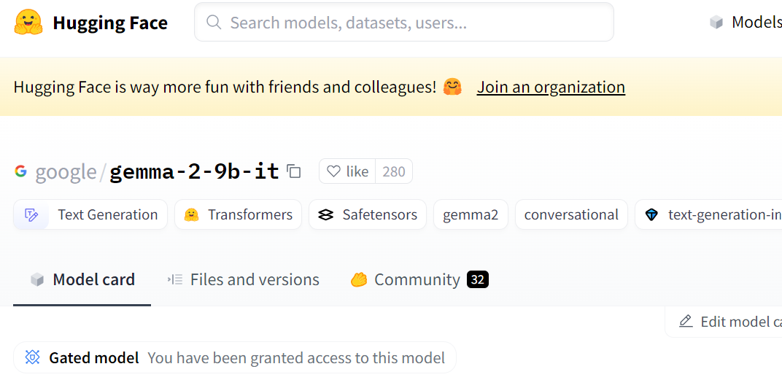
5- groq introduction - groq cloud - save the gemma model using -- gemma2-9b-it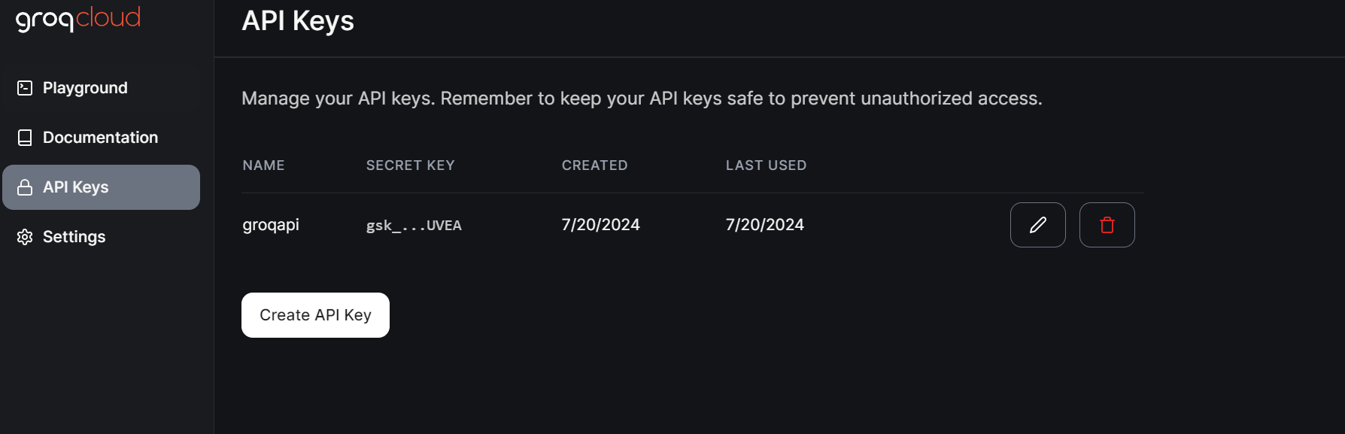
6- PRACTICLE:1 GEMMA MODEL INTEGRATE WITH HUGGING FACE
https://github.com/huggingface/transformers

7- PRACTICLE:2 GEMM MODEL INTEGRATE WITH LANGCHAIN, HUGGING FACE & GROQ

8- PREVIOUS YOUTUBE VIDEOS

